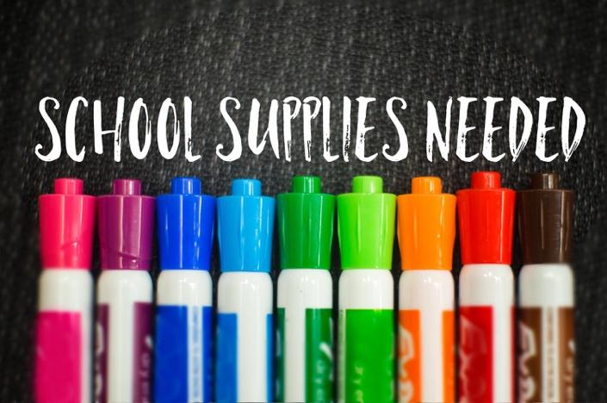

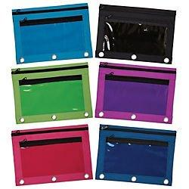

1 (1-inch) 3 ringed binder with clear pocket on front

1 ( 5 pack) 3 whole punch colored dividers **WITH POCKETS**

**( Red, Blue, yellow, Green, Orange)**

1 pencil pouch with zipper (clear window preferred)

8 black dry erase markers

1 box of Ziploc ( Girls: Gallon size, Boys: sandwich size) 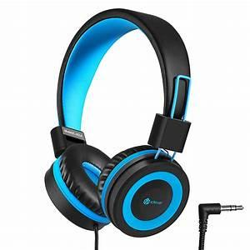

2 spiral notebooks ( green, yellow)

1 plastic prong folder **with pockets**

1 composition book ( student choice on color/design)

8 glue sticks

1 pair of wired headphones (labeled with student’s name)  
1 pack of 3 x 5 white index cards

3 packs of Ticonderoga Brand SHARPENED pencils

2 (24 pack) Crayola crayons

1 pack of crayola colored pencils  
2 boxes of tissues GIRLS  
2 boxes of cap erasers BOYS  
8 multi color highlighters

1 container of Clorox wipes

1 pair of scissors ( labeled with your child’s name)

1 packets wide ruled lined paper

1 bag individually wrapped candy ( Hershey kisses, Smarties, Starburst etc)

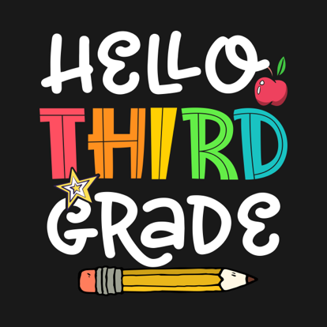

**Wish List**

Colored Pencils  
Extra Sticky notes

Scotch tape refills

Paper clips

Elmer’s white glue